SIMATS ENGINEERING (SAVEETHA SCHOOL OF ENGINEERING)
Department of Computer Science and Engineering

ASSESSMENT TOOL 3 – CASE STUDY

Course Code: | CSA06 | Course Title: | Design and Analysis of Algorithms
CO Assessed: | CO3: Articulation (BL4, BL5) | Assessment: | Assessment Tool 2 – Case Study
Weightage: | 20% of CIA | Total Marks: | 100 (2 Questions × 50 Marks)
CO3 Statement: | Design Divide and Conquer algorithms for Merge Sort, Quick Sort, Binary Search and Matrix Multiplication
Student Name: | CH AKHIL | Reg. No.: | 192525250
Section / Batch: | 2025 | Date: | 17-08-2026

Instructions to Students
- Answer both questions. Each question carries 50 Marks. Total: 100 Marks.
- Carefully analyze the given case study questions.
- Explain in detail with sample code if needed.
- Clearly identifies all key issues, in-depth analysis, Innovative, feasible solutions with strong justification

Question Type | Description | Questions | Total Marks
Case Study | Focus on Design Divide and Conquer algorithms: Merge Sort, Quick Sort,  Binary Search and Matrix  Multiplication | Q1 – Q2 | 100

SECTION A – CASE STUDY

CASE STUDY: DIVIDE AND CONQUER IN LARGE-SCALE DATA PROCESSING

1. Introduction
A university stores thousands of student records containing student IDs, marks, attendance, and other academic information. Processing such a large amount of data efficiently is important for generating reports and finding student information quickly.
The Divide and Conquer technique provides an effective solution. It divides a large problem into smaller subproblems, solves each subproblem, and then combines their results. The CO3 syllabus specifically focuses on Merge Sort, Quick Sort, Binary Search, and Matrix Multiplication using this approach.

Image 1: Divide and Conquer Process
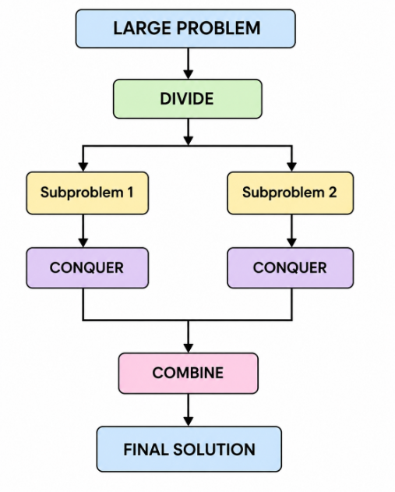
2. Application of Divide and Conquer Algorithms
A. Merge Sort
Merge Sort divides the student records into two halves. Each half is sorted separately and then merged to produce one sorted list.
Example:
If the student IDs are:
45, 12, 78, 23, 9, 34
They are divided into smaller parts, sorted, and finally merged:
9, 12, 23, 34, 45, 78
Time Complexity: O(n log n)
Merge Sort is useful when predictable performance and stable sorting are required.

B. Quick Sort
Quick Sort selects an element as a pivot and divides the records into two groups: elements smaller than the pivot and elements greater than the pivot.
The two groups are then sorted recursively.
Average Time Complexity: O(n log n)
Worst Case: O(n²)
Quick Sort is useful when fast in-memory sorting is required.

C. Binary Search
After student records are sorted according to student ID, Binary Search can quickly locate a particular student.
For example, instead of checking 10,000 student records one by one, Binary Search repeatedly checks the middle record and eliminates half of the remaining records.
Time Complexity: O(log n)
This makes Binary Search highly efficient for searching large sorted datasets.

D. Matrix Multiplication
Universities may use matrices for academic analytics, statistical calculations, or other computational tasks. Large matrices can be divided into smaller submatrices.
Each smaller matrix is multiplied separately and the results are combined.
Standard Time Complexity: O(n³)
The divide-and-conquer approach provides a structured way to handle large matrix operations.

3. Case Analysis
Suppose a university has 50,000 student records.
Requirement | Suitable Algorithm | Reason
Sort student records | Merge Sort | Predictable O(n log n)
Fast in-memory sorting | Quick Sort | Efficient average performance
Find student by ID | Binary Search | O(log n) searching
Perform matrix-based analysis | Matrix Multiplication | Handles large mathematical operations

Image 2: Algorithm Selection
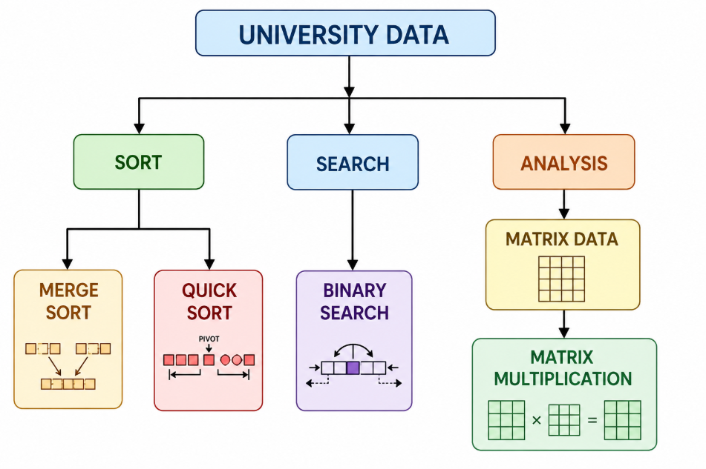
4. Solution Design

For this case study, the university can use a combination of all four algorithms.
Step 1: Use Merge Sort or Quick Sort to organize student records.
Step 2: Once the records are sorted by student ID, use Binary Search to find students quickly.
Step 3: Use Matrix Multiplication for mathematical and analytical operations involving large datasets.
This approach reduces unnecessary processing and makes the system more organized and scalable.

5. Advantages
- Reduces a large problem into smaller manageable problems.
- Improves algorithm efficiency.
- Suitable for processing large datasets.
- Binary Search provides very fast searching.
- Merge Sort provides predictable performance.
- Quick Sort is efficient for practical in-memory sorting.
- Matrix division provides a structured approach to large mathematical operations.

6. Conclusion
This case study demonstrates how Divide and Conquer can be applied to a real-world university data-processing system. Merge Sort, Quick Sort, Binary Search, and Matrix Multiplication solve different parts of the problem efficiently.
By dividing large problems into smaller subproblems, solving them independently, and combining the results, the university can achieve better performance and scalability. Thus, Divide and Conquer is an important technique for designing efficient algorithms for large-scale applications.

Code of Conduct
I CH AKHIL(192525250) (Name / Reg No) certify that this submission is my original work and that I have adhered to the guidelines specified for this assessment. I understand that any violation of academic integrity rules will result in disciplinary action.
Signature of the Student: CH AKHIL

RUBRICS FOR CALCULATION

 |  | Case Study
Criteria | Weightage | Level 4 –  Exemplary | Level 3 –  Proficient | Level 2 –  Developing | Level 1 –  Beginning
Understanding of Case | 25 | Thorough understanding; clearly  identifies all key issues | Good understanding with most issues identified | Basic understanding;  some issues missed | Poor understanding;  problem not  identified correctly
Application of Concepts | 25 | Effectively applies relevant concepts to  analyze the case deeply | Applies appropriate  concepts with minor gaps | Limited application of concepts | Fails to apply relevant concepts
Analysis | 20 | In-depth analysis with strong  reasoning and insights | Good analysis with logical reasoning | Basic analysis with limited depth | Weak or no analysis; lacks reasoning
Solution Design | 20 | Innovative, feasible  solutions with strong justification | Logical solutions with adequate justification | Basic solutions with weak  justification | Incorrect or no solution provided
Clarity | 10 | Clear, well-structured, and easy to understand | Organized and understandable presentation | Limited clarity and structure | Poor clarity; difficult to understand
Mark Evaluation:

Case Study | Understanding  of case  (25) | Applications of concepts  (25) | Analysis  (20) | Solution  Design  (20) | Clarity  (10) | Total  Marks  (Each -  50)
Q1
Q2
 |  |  |  | Overall Total (100)

Faculty In-charge | Course Coordinator | Head of Department
Name: __________________  Signature: _______________ | Signature: _______________ | Signature: _______________
Date: ___________________ | Date: ___________________ | Date: ___________________

